# Manual of Plugin: LentiManager

-- Power by DHM(huimingdeng).

### Lentivirus Management list

1. Click on the "A" icon to download the current usage document.

2. Click the add button in position "B" to add a single lentivirus message. For example, the picture 2, fill in information about lentivirus and save the publication.

3. Click the "template" button of position C to download the imported template in batch. When completed, click "uploads" button to upload lentivirus information.

4. Click the icon button in position D to modify the lentivirus information.

5. Click the icon button in position E to delete lentivirus information.

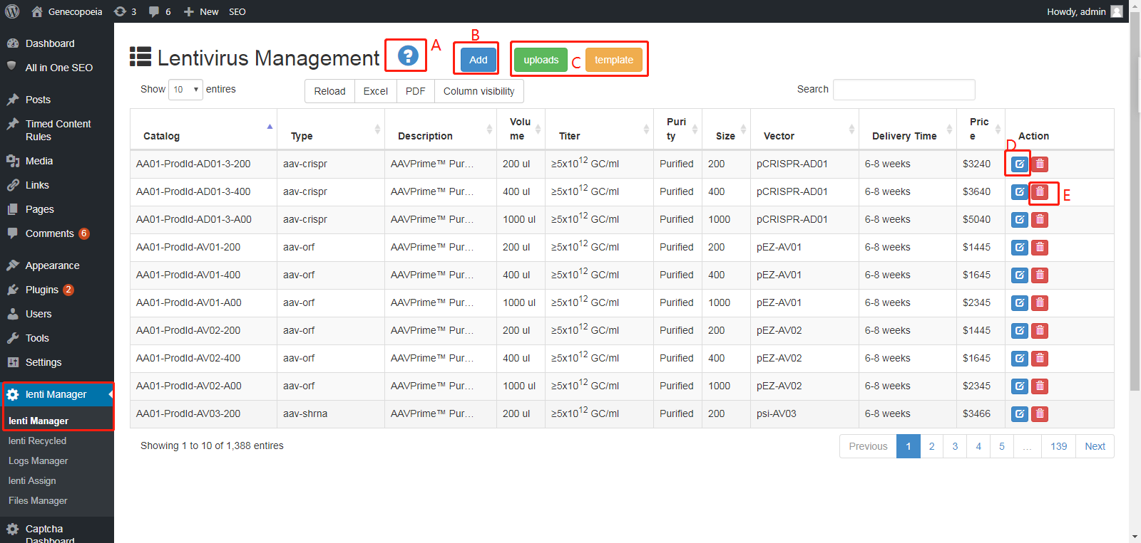

**Picture One**

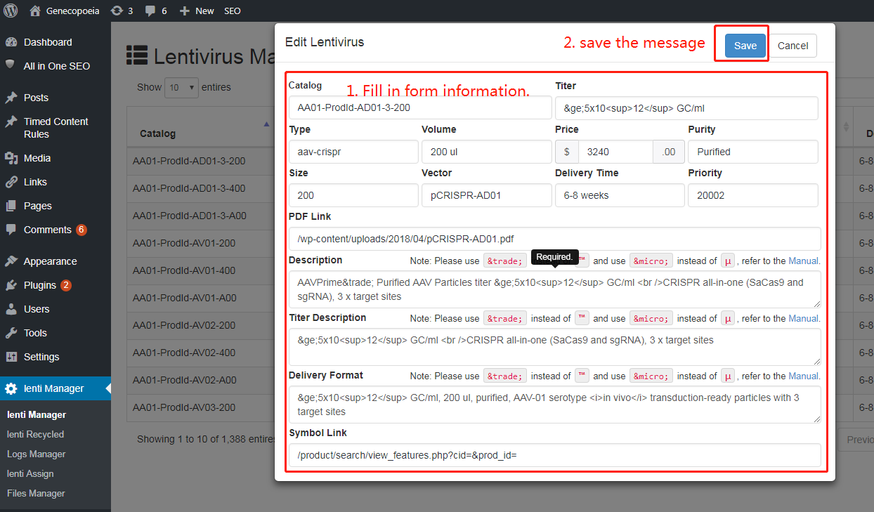

**Picture Two**

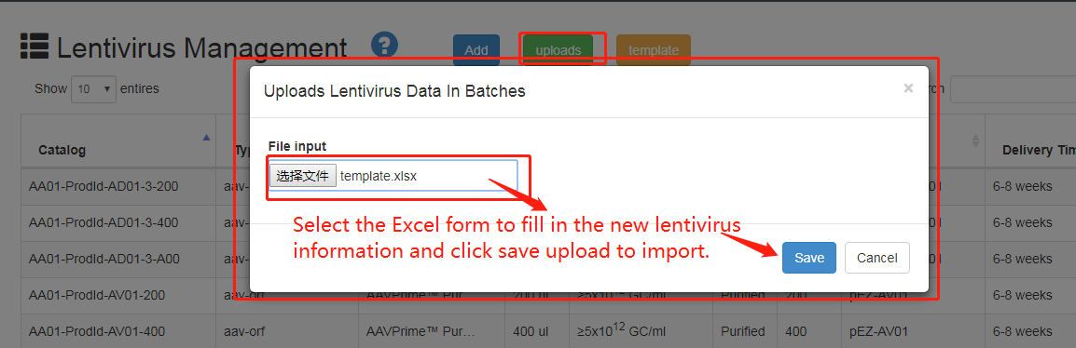

**Picture Three**

### Lentivirus Recycled Management

6. As shown in position F, check the check box and click the blue "Restore" button to Restore the deleted lentivirus information in batches.

7. As shown in position G, click the green "Restore" button to Restore single deleted lentivirus information.

